Buffalo Farm Equipment Helping you Grow ….
Pump Sizing Questionnaire - Selecting the right pump for the job is essential

Name: _________________________________________________________________________________
Address: _______________________________________________________________________________
Postcode: ________________ Phone/Mobile: ________________________________________________
Email Address: __________________________________________________________________________
Buffalo Farm Equipment is a water specialist with well trained staff in the principles of pump operation and pump selection. To assist, take a few minutes to gather some basic information and send this completed form to b.farm@bigpond.net.au

- For what purpose do you require a water pump?
Household water pressure
Garden watering / sprinklers
Irrigation
Stock water supply
Hosing down
Tank filling
Firefighting
Other (specify) __________________________________

1a. Operating pressure required (if known) _____________ kPa
- Total output required (if known) __________________ L/min
OR Total no. of taps to be serviced at one time: ___+++_____
- From what source of supply is the water to be drawn?
River, creek, channel
Dam
Rainwater tank (above ground)
Underground tank
Bore
Spear point
Other (specify) ___________________________________
 
3a. Water supply: clean, muddy or gritty? ___________________
3b. If bore, state inside diameter of casing _________________
Bore depth ______________________________________m
3c. If water is to be drawn from bore, state the quantity of water the bore will deliver _______________________________L/min From what constant depth? ____________________________m
What is the standing water level in the bore? _____________m

- Vertical suction lift from water supply level to the pump site? ________________________________________________m
- Pipe length to be run on suction side of pump from applications other than a bore ________________________m
- Diameter of suction pipe, if already laid ______________mm Type of pipe e.g. polythene metric or imperial, galvanised iron, PVC, other (specify) __________________________________
- Vertical height from pump to highest point of
delivery _______m
- Pipe length to be run on delivery side of pump _________m
- Diameter of delivery pipe, if already laid _____________mm and type of pipe e.g. polythene metric or imperial, galvanised iron, PVC, other (specify) _____________________________
- Type of pump required:
Automatic Pressure System
Petrol Engine Driven Pump
Manual Electric Pump
Diesel Engine Driven Pump
Other (specify) ____________________________________

- If electric, voltage of electricity supply is:
1 phase | 240 volt OR 480 volt
3 phase | 415 volt
Other | Other ( Please specify)  ____________________________________

12. If replacing an existing pump, please give details:

Make: _____________________________________

Model: ____________________________________

Were you happy with the performance of the old Pump?
_______________________________________________________
_______________________________________________________

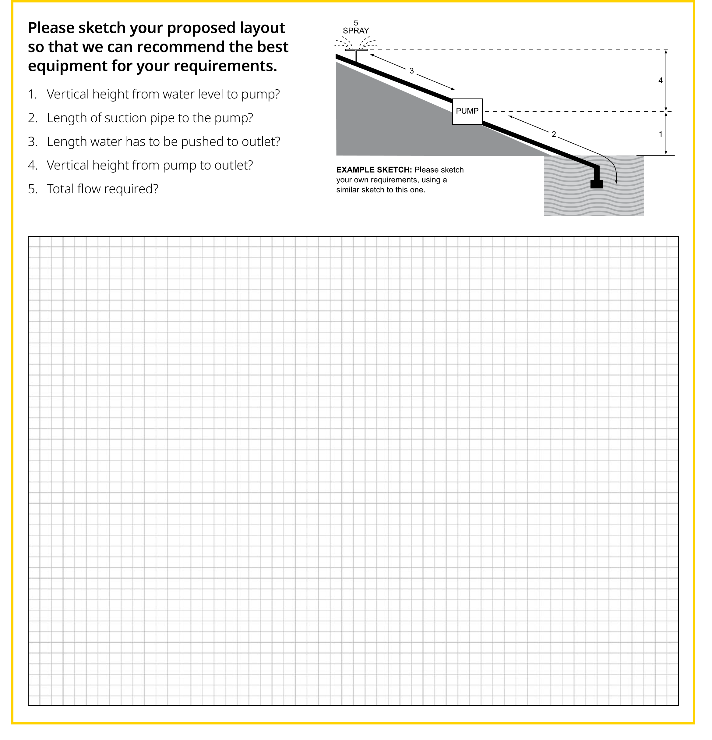

Notes:

Buffalo Farm Equipment | Helping you Grow ….
A.B.N. 54 810 620 954

62-66 Myrtle Street Myrtleford Vic 3737 Tel: 03 5752 1422 Fax: 03 5752 2534 Email: b.farm@bigpond.net.au
www.buffalofarmequipment.com.au
Buffalo Farm Equipment Helping you Grow ….

Common Average Water Requirements
The average water requirements, shown below, may vary due to specific application concerns. Water requirements should be supplied within acceptable daily running times. This time will vary according to the nature of the application.

SHOWER: 15 lpm at 140 kPa (3.3 gpm at 20psi) | CATTLE: 30-55 litres/day (6.5 – 12 gallons/day)
LAWN SPRINKLER: 15 lpm at 140 kPa (3.3 gpm at 20psi) | MILKING COWS: 70 litres/day (15.4 gallons/day)
½” TAP: 12-15 lpm at 140 kPa (2.6 – 3.3 gpm at 20psi) | SHEEP: 5 – 10 litres/day (1-2 gallons/day)
¾” HOSE & ¼” NOZZLE: 40 lpm at 210 kPA (8.8 gpm at 30psi) | PIGS: 10 litres/day (2 gallons/day)
1’ HOSE & 3/8” NOZZLE: 75 lpm at 210 kPa (16.5 gpm at 30psi) | HORSE: 55-60 litres/day (12 – 13.2 gallons/day)
100 CHICKENS: 25 litres/day (5.5 gallons/day)

SUCTION LIFT
Pumps do not actually suck: rather, pumps create a partial vacuum into which atmospheric pressure pushes water via the suction pipework. There are a number of factors which affect suction life:
Altitude: As altitude increase, atmospheric pressure decreases, thus exerting less “push” on the water entering the pump suction.
Pump Suction Performance: Generally, the higher the flow rate from the pump, the less the partial vacuum created by the pump.
Water Temperature: The higher the water temperature, the more likely it is to boil when exposed to a partial vacuum, thus reducing suction lift.
Friction Loss: Friction loss in the suction pipe reduces the vertical life possible.

In practical terms, a maximum suction lift of 6.7 metres at sea level is common, but all of the items above will reduce this figure.

Suggested Max Flows for Imperial Poly Pipe:

¾” | 18 L/M
1” | 27 L/M
1¼” | 45 L/M
1½” | 67.8 L/M
2” | 113.4 L/M

